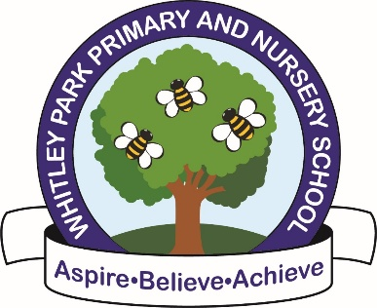

**Proposal to lower the age at Whitley Park Primary and Nursery School, Reading RG2 7RB**

This is notice that the Governing Body of Whitley Park Primary & Nursery School, intends to lower the age range of pupils at the school from 3 to 11 years to 2 to 11 years, with effect from 1 September 2025. Further details are on our website.

Within four weeks from the date of publication of this proposal, any person may object to, support or make comments on the proposal, please select and comment below:

1. Name
2. Please select one of the following

Parent

Childcare Provider  
 Other

3. Please select one of the following:

We object to the proposal

We support the proposal

We remain neutral to the proposal

1. If you have any comments, please provide them below:

***Date of Publication – 12th May 2025***

If you have any questions relating to this proposal please contact Allison Dench, School Business Manager at [**admin@whitleypark.reading.sch.uk**](mailto:admin@whitleypark.reading.sch.uk)   
Responses will be shared with:

* Whitley Park Primary School & Nursery leadership
* Brighter Futures for Children & Reading Borough Council teams as appropriate and for decision