

Starting nursery

In September I will start nursery

**Insert name of setting**

© Brighter Futures for Children 2025

I will walk to nursery

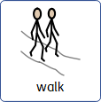

Nursery starts at 9am

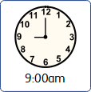

This is where I put my coat.

I will put my lunch box on   
the trolley.

This is my classroom.

There are lots of things to do and play with.

The teachers in my class   
will be:

Name

Name

There is a play area outside

Playing and having fun can make me hungry.

This is where I will have   
a snack.

I will have my own water bottle with my photo on it.

This is the bathroom where I will wash my hands and   
use the toilet.

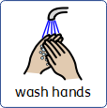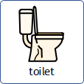

This is where I will   
eat my lunch.

There are other children having lunch too and it can be a little noisy but that is ok.



At 3pm nursery finishes   
for the day.

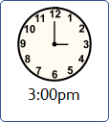

I put on my coat and bag.

When I see my mum we   
walk home.

