

**Starting school**

In September I will start my new school

**Insert name of school**

My parents will walk with me to school each day and pick me up after school has finished.

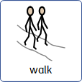

School starts at 8.50am

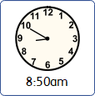

I will hang my coat and bag up in the coat area.

I will put my lunch box on the trolley.

When I go to school, I will wear a uniform like this.

I will be in Reception class.

In my class there are lots of things to do and play with.

The teachers in my class will be:

There is an outside area where I can play at break and   
lunch time.

Playing and having fun can make me hungry.

My teacher will tell me when its snack time and I will go to the carpet area.

I will have my own water bottle for drinking.

This is the toilet area.

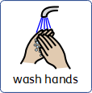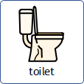

At lunch time I will go to the dinner hall to eat my lunch.

There are other children in the dinner hall and it can be a little noisy but that is ok.



At 3pm school finishes for the day.

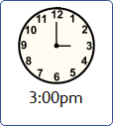

I put on my coat and bag.

When I see my mum we walk home.

