About this information (this is not a referral)
- The person helping me fill this form in has explained to me that Brighter Futures for Children will hold a copy of this document. I agree to my personal information and that of the children I have parental responsibility for, being shared between agencies to ensure I receive the best support for my family.

- Everyone in my family has helped to fill this in and the children have had the chance to share how they are feeling.

- I agree with the information provided and that it is a true record of my family and their needs.

Signed:  (If signature cannot be provided, please tick to confirm parent/carer has read and is happy with the information provided and provides consent) | Date started: Click or tap to enter a date.  Date completed: Click or tap to enter a date.

Details of person completing this form with me
Name: |  | Setting:
Job Role: |  | Email:

About my family
Family Name(s):
Family Address (including postcode):
Telephone number:

Children in my family
Name (including unborn) | D.O.B | Gender | Relationship to parent/carer living in the household | Parental responsibility (Y/N) | Religion | First language | Disability | SEN Support Y/N | EHCP Y/N | Name of school/ Nursery/ College

People who are important to my family including other family members, friends, people in community?
Name (including unborn) | D.O.B. or age | Gender | Relationship to parent/carer living in the household | Disability/Additional needs | Address | To be included in TAF meetings? Y/N

People who are helping me now or have helped me already
Their name | Supporting who | Role/Agency | Current/Past | How did this help?

What we need help with (this must be filled in)
 | We need help with | Who is concerned |  | We need help with | Who is concerned
Housing |  |  | Child development under 5’s
Parenting |  |  | Child development age 5+
Parental relationships |  |  | Health – adult
Finances |  |  | Health – child
Mental Health – adult |  |  | Domestic abuse
Mental Health - child |  |  | Bereavement
SEND |  |  | Safety
Peer relationships |  |  | Accessing community
School attainment |  |  | Relationships with school
School attendance |  |  | Other

Please briefly consider the following questions and provide a few bullet points.
I need help with these because…

My family strengths | What could be better and what is getting in the way?

If nothing changes for us, how will it impact my family?
School and early years achievements (to be completed by a professional at education setting)
 | Child 1 | Child 2 | Child 3 | Child 4 | Child 5 | Child 6
Child’s name:

Current attendance:

What are they doing well in?

What do they need help with?

Who do they go to for support if they need it?

What do the children/young people say? (Please score each area from 1 to 5, 1 being poor, 5 being great)

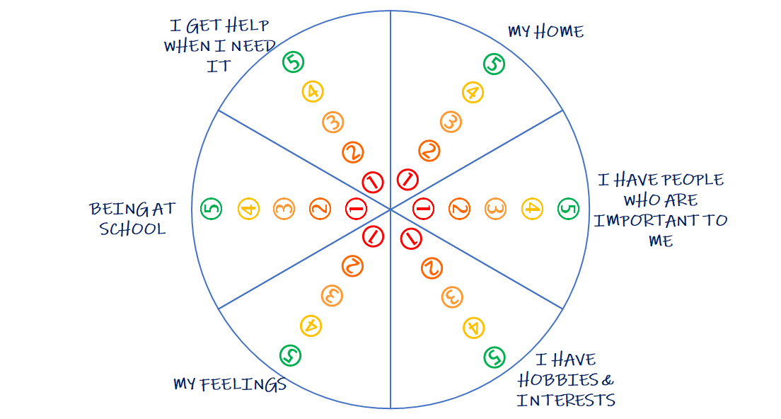
Anything you’d like to add?

