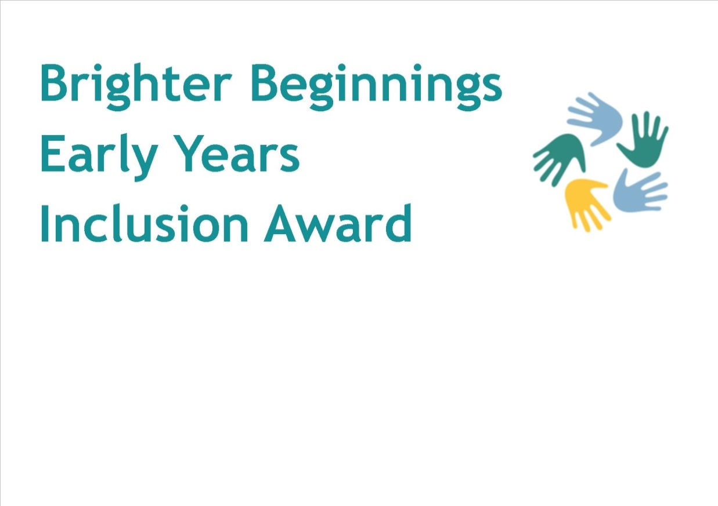

**Level 1t steps Guide**

**Level 1 Next Steps Guide**

Thank you for registering for the Level 1 Brighter Beginnings Early Years Inclusion Friendly Setting Award! You may now be thinking, what do I do next?

This guide has been put together by the Brighter Beginnings Panel representatives to help settings in their journey towards achieving the award.

Once you decide to take this next step in working towards your journey, please email [Brighter.beginnings@brighterfuturesforchildren.org](mailto:Brighter.beginnings@brighterfuturesforchildren.org) requesting a consultation with a member of the Panel to go through the first steps and identify what training will suit your setting. Please note this will begin the process and we will invoice £150 to enable accessing the training & support for all 3 levels.

|  |
| --- |
| **Firstly, set aside some time** to focus on the award. For example, you could designate 10-20 minutes of all future team meetings to cover ‘being an inclusion-friendly setting’.  Many settings in Essex who have achieved the Good Beginings award, stress the importance of having full support from your team.   * ***You can scan and send us team meeting agendas and minutes as part of your evidence or even photos!*** |
| **Familiarise yourselves with the** [AET standards for early years settings.](https://www.autismeducationtrust.org.uk/resources/early-years-standards-framework)  Reflect on your provision in relation to the standards and record this on the document. Develop an action plan in conjunction with the Early Years team member who supports your setting and revisit this action plan with your team regularly     * ***You can send us your completed standards and action plan as part of your evidence.*** |
| Plan some fun activites to get your team learning about inclusion, you can use this staff [Inclusion confidence audit](https://search3.openobjects.com/mediamanager/reading/enterprise/files/inclusion_confidence_audit.pdf) to understand more about their knowledge. You can then create a team training plan detailing what SEND training all staff or indvidiual staff may need to support their learning and development *(Complete training plan will be discussed at initial consultation visit with EY team)*.  Inclusion Continous Professional Pevelopment (CPD) may include:   * Dingley’s Promise online training – there wil be 10 modules avaliable over the next few years. All staff need to individually register here: <https://dingley.org.uk/dingleys-promise-training/early-years-inclusion-programme/> * Bespoke Whole Setting Training from Local Authority Trainers. * [NASEN Online Training & Webcasts](https://nasen.org.uk/early-years) (Inclusion Lead can use this free online resources to deliver training to their staff too) * [A is for autism video](https://www.youtube.com/watch?v=zxt3FBVq8Jg) * [Animal School](https://www.youtube.com/watch?v=pV99kLUJS5A) * ICAN Training   Consider asking your team to complete this [CPD reflection form](https://search3.openobjects.com/mediamanager/reading/enterprise/files/cpd_reflection_form.pdf) once they have received any Inclusion and SEN training, which can include watching the videos above and provdiing their viewpoints following this.   * ***You can send us your team’s quiz entries, training certificates and reflection forms as part of your evidence.*** |
| **Get networking!** If you don’t already contact other providers in your area, consider getting to know other settings in your area. You can share advice and best practice, ask questions about how they are autism friendly and organise visits. (*A list of settings who have already achieved the award will be published on the Family Information Service Page*)  Come along to one of the Termly [Early Years Inclusion Funding Panel’s](http://search3.openobjects.com/kb5/reading/directory/advice.page?id=oeI4dFGrQZ0) to discuss children’s needs, meet other settings and gain advice from the Early Years Multi Agency SEN Teams.  Don’t forget after-school clubs and children’s centres as well as other day nurseries, preschools, Schools and childminders.   * ***You can send us email trails, invitations to networking events or photos as part of your evidence.*** |
| **Share the news!** Create an ‘Inclusion” display (or folder) to include all four areas of the code of practice in the setting. Include a photo of the SENCO /Inclusion Lead.  Invite your team, visitors and families to ask questions about the content and the Brighter Beginnings Award.    You can send us a few photos of your board as evidence and make sure its regularly maintained. |
| Familiarise yourself with the [Reading Local Offer](http://servicesguide.reading.gov.uk/kb5/reading/directory/family.page?familychannel=3), and the [Graduated Response for Early Years](https://search3.openobjects.com/mediamanager/reading/enterprise/files/early_years_graduated_document_final_1.pdf) to look for **services and providers in your area** that may be helpful to the children in your setting and their families, these may include Speech and language therapists, support groups or services in your local community, etc.   * ***You can send us evidence of referral forms or contact details that your setting may come across when supporting a child with SEN.*** |
| * ***You can send us photos or scanned copies of the following as evidence that you are taking into consideration every child’s needs and that every child is unique.***   ***(remember to cover any full names or photos of children):***   * One page profile * Good day/bad day * Home/setting communication books * Learning journey * Early Years Developmental Journal Tracking. * Dreams and aspirations * Observation profile. * Inclusion/SEND policy.   Find out more information about Individual Education Support Plans in the [Early Years SENCO Guidance Document](https://search3.openobjects.com/mediamanager/reading/enterprise/files/early_years_senco_guidance_2020.pdf) on the Reading Local Offer  Let us know how you share and store this information. For example, are one page profiles for each child displayed on the wall for all staff to see or in a folder at a childminder setting? |
| **Update your policies and induction plan** to include Special Educational Needs and Disability.  Consider what SEN related training you want any new team members to complete when joining the team. Ensure you discuss the Inclusion Award with any new members of staff. |
| **Keep up to date** with relevant information by joining the Early Years Advisory Teacher mailing list by emailing [Aimee.Trimmer@brighterfuturesforchildren.org](mailto:Aimee.Trimmer@brighterfuturesforchildren.org)  Relevant legislation includes: the SEND Code of Practice, the Children & Families Act, The Equality Act and the EYFS. You can refer to the [Early Years SENCO guidance document](https://search3.openobjects.com/mediamanager/reading/enterprise/files/early_years_senco_guidance_2020.pdf) for more information about this.  Feedback information to your team and send us screenshots or photos as evidence. |
| **Once you have sent in all of your evidence and checked you have met each of the criteria send us a completed** [Submission of evidence form](https://search3.openobjects.com/mediamanager/reading/enterprise/files/evidence_portfolio_list.pdf).  We will then take your portfolio of evidence to the next panel. Panels will be held regularly. Always assume panel members know nothing about your setting. Evidence must be clearly cross referenced.  We let you know the outcome within a week of Panel taking place.  Professionals will be asked to endorse the evidence of settings they visit and support, to confirm that it is a true account of the activities undertaken. |

**Hints and Tips**