Starting School

In September I will start my new school

Add photo

Insert name of school

My mum or dad will walk with me to school each day and pick me up after school has finished.

Add photo

School starts at 8:50am
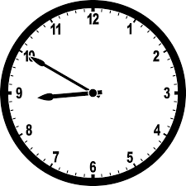
I will hang up my coat and bag in the cloakroom area. I will put my lunch box on the trolley.
Add photo

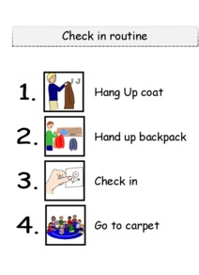

When I go to school, I will wear a uniform like this.

Add photo

I will be in reception class.
Add photo

There are lots of things to do and play with.

Add photo

Add photo

Add photo

Add photo

Add photo

Add photo

Add photo

Add photo

The teachers in my class will be…

Add photo

Add photo

There is also an outside area to play.

Add photo

Add photo

Add photo

Add photo

Playing and having fun can make me hungry, this is where I will have a snack.

Add photo

I will have my own water bottle with my name and picture on to have a drink.

Add photo

When I need the toilet, I can use the reception toilets near my class.

Add photo

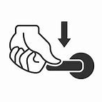

I will try to remember to flush the toilet and wash and dry my hands.
At lunch time I will go to the dinner hall to eat my lunch.

Add photo

There are lots of children in the dinner hall and it can be a little noisy but that is ok.

Sometimes we go to the orchard or we play sports in the mugger.

Add photo

Add photo

Add photo

At 3.00pm school finishes.
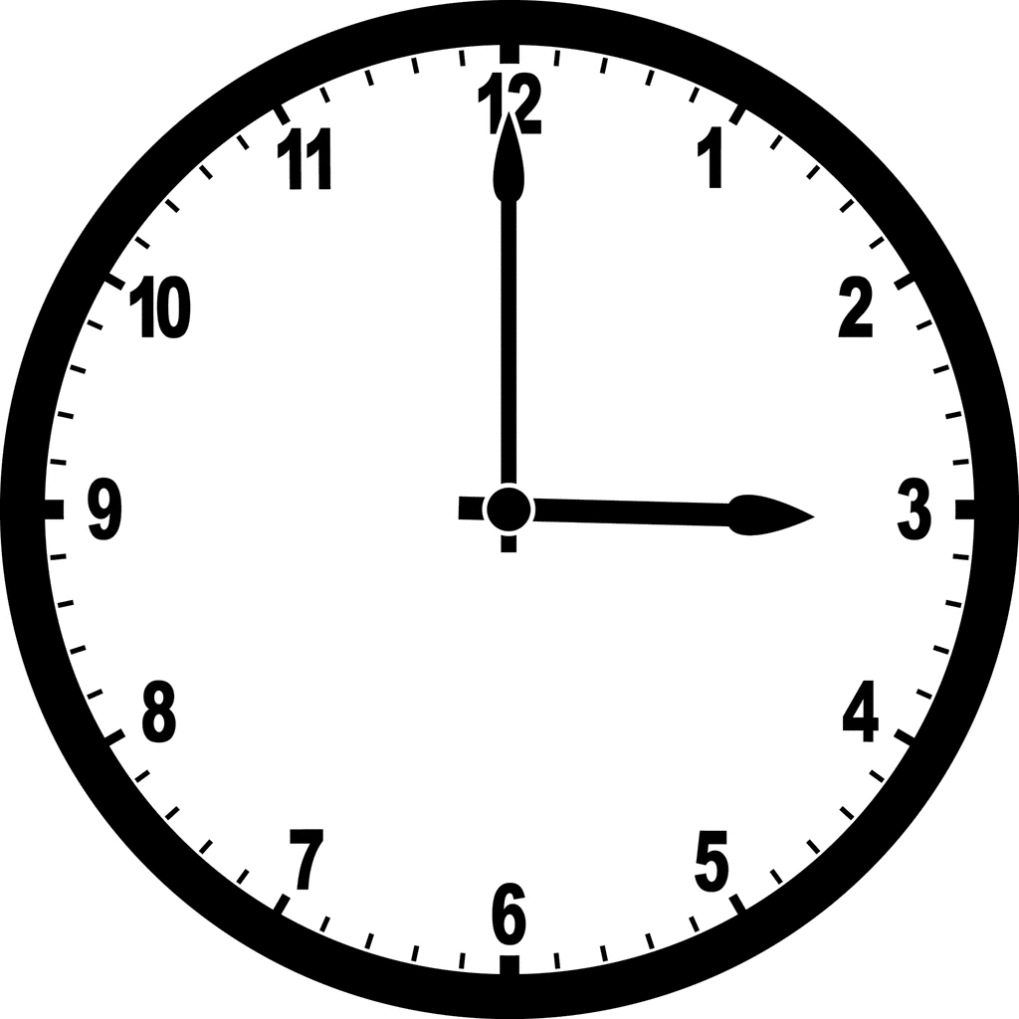
When the bell rings I get my coat and bag then line up at the door. I wait for my turn to to leave the class and meet my mum or dad so we can go home.

Add photo

