Starting Nursery

In September I will start Nursery

Add photo

Insert Name of setting

My mum will walk with me to nursery and collect me after nursery has finished.

Add photo

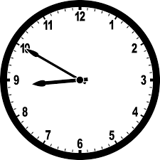
Nursery starts at 8:50am

I will hang my coat and bag up in the cloak area. I will put my lunch box on the trolley and then put my photo on the wall.
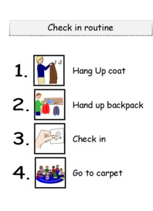

This is my classroom.
Add photo

There are lots of things to do and play with.
Add photo

Add photo

Add photo

Add photo

Add photo

Add photo

Add photo

Add photo

The teachers in my class will be…

Add photo

Add photo

There is also an outside area to play.
Add photo

Add photo

Add photo

Add photo

Playing and having fun can make me hungry, this is where I will have a snack.
Add photo

I will have my own water bottle with my name and picture on to have a drink.
Add photo

This is the bathroom where I will wash my hands and use the toilet.

Add photo

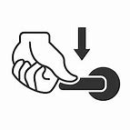

I will try to remember to flush the toilet, wash and dry my hands.
At lunch time I will go to the dinner hall to eat my lunch.

Add photo

There are lots of children in the dinner hall and it can be a little noisy but that is ok.

Sometimes we go to the orchard or for a walk.
Add photo

On outings I will hold hands with my teacher and stay close to her.
Add photo

At 3:00pm nursery finishes for the day.
I put on my coat and bag. When I see my mum we walk home.
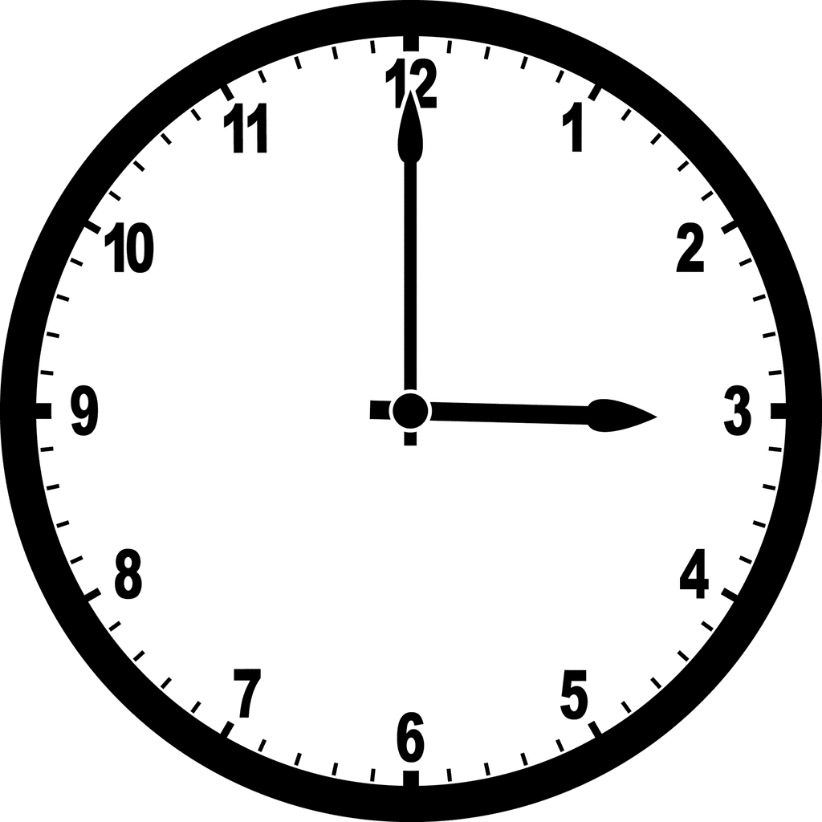
Add photo

