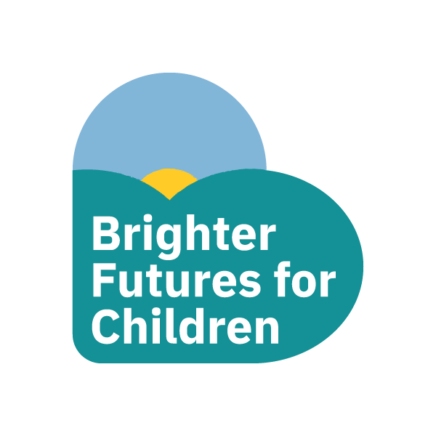

To find out more or to get in touch:

Email: [ReadingChildrenCentres@brighterfuturesforchildren.org](mailto:ReadingChildrenCentres@brighterfuturesforchildren.org)

Facebook: www.facebook.com/Readingchildrenscentres

Website: www.brighterfuturesforchildren.org

**Or you can visit us at one of the Children’s Centres below:**

**West Cluster:** Ranikhet, Spey Rd & Battle Library, Oxford Road, RG30 1EE

**South Cluster:** Whitley Childrens Centre, Northumberland Ave, Whitley, RG2 7QA

**West Central Cluster:** Southcote hub**,** Coronation Square, Southcote, RG30 3QP & St Mary and All Saints School, Wensley Road, Coley, RG1 6DU.

**East Cluster:** Sun Street Children’s Centre, Sun Street RG1 3JX & Caversham Childrens Centre, Amersham Road, RG4 5NA

**Your Children’s Centre journey will begin with your antenatal appointments within one of our centres.**

**Community Midwife direct contact: 0118 322 8059.**

**You will also be invited to attend group antenatal sessions at one of the centres run by your local health visitor.**

**Midwife Clinics** run from Sun Street, Caversham, Southcote and Ranikhet Children’s Centres.

**Health Visiting Team:**

**Child Health Reviews -** you should receive a letter from your health visiting team inviting

you to book an appointment for your child’s 9 month or 2 year Health Review. These generally take place in the Children’s Centres.

(If you do not receive a letter please contact: **0118 931 2111** or email: bks-tr.readingdutyhv@nhs.net)

**WEANING TALKS:** Ranikhet - 21st Nov, 23rd Jan & 20th March: Whitley 5th Dec: Caversham 7th Nov: Southcote 19th Dec & 20th Feb ( **0118 931 2111** to book your place)

**Volunteering & Adult learning**

**Accredited English, Maths and Childcare courses- Did you know you could access a FREE crèche place within some centres to enable you to study**

**Family Learning sessions** are delivered by the Children’s Centres in partnership with New Directions.

These sessions are for you and your child/children to do together, a stepping stone to further learning.

**Employment Advisor –** call your local Children’s Centre for an appointment.

**Volunteering opportunities** are available in some centres or for community volunteering opportunities please email: advice@rva.org.uk.

**Parenting Groups**

We offer parenting groups, which can be accessed via your local children’s centre. Our offer to you is to provide free parenting courses to ensure you’re ready for any challenges ahead.

Please contact us if you would like to find out more or for us to make your referral to access this support.

Email: readingchildrencentres@brighterfuturesforchildren.org

Facebook: www.facebook.com/Readingchildrenscentres

Website www.brighterfuturesforchildren.org

**Or you can call us on one of the numbers below**

**West Cluster:** 0118 937 5221

**South Cluster:**  0118 937 3894

**West Central Cluster:** 0118 937 2535

**East Cluster:** 0118 937 4602

**Our Children’s Centre Offer Includes:**

**Universal Health Offer-** including midwifery, child health reviews, child health clinics and speech and language support.

**Bumps and Babes** - (for infants aged 0-12 months) New parent support and advice.

**Children's Centre Family Workers -** offer support to meet individual family needs, referral is via Reading’s Single Point of Access: http://www.brighterfuturesforchildren.org

**Together Time with F.A.M.I.L.Y - (For Infants, Toddlers and Pre-schoolers - under 5s)** This session is planned to support your child with school readiness and to offer parents additional support based on individual family need.This includes emerging or diagnosed Special Educational Needs and Disabilities - we offer support to access advice and guidance and work in partnership with Reading Families Forum.

**Two year olds** – If you are on a low income or accessing benefits, you might be eligible to apply for 15 hours a week of **FREE** early education or childcare for your two-year-old. To find out if you’re entitled please visit www.brighterfuturesforchildren.org or call us on 0118 937 3777 option 2. Or call the Family Information Service on 0118 937 3777 (option 2 )

**Reading Children’s Centres**

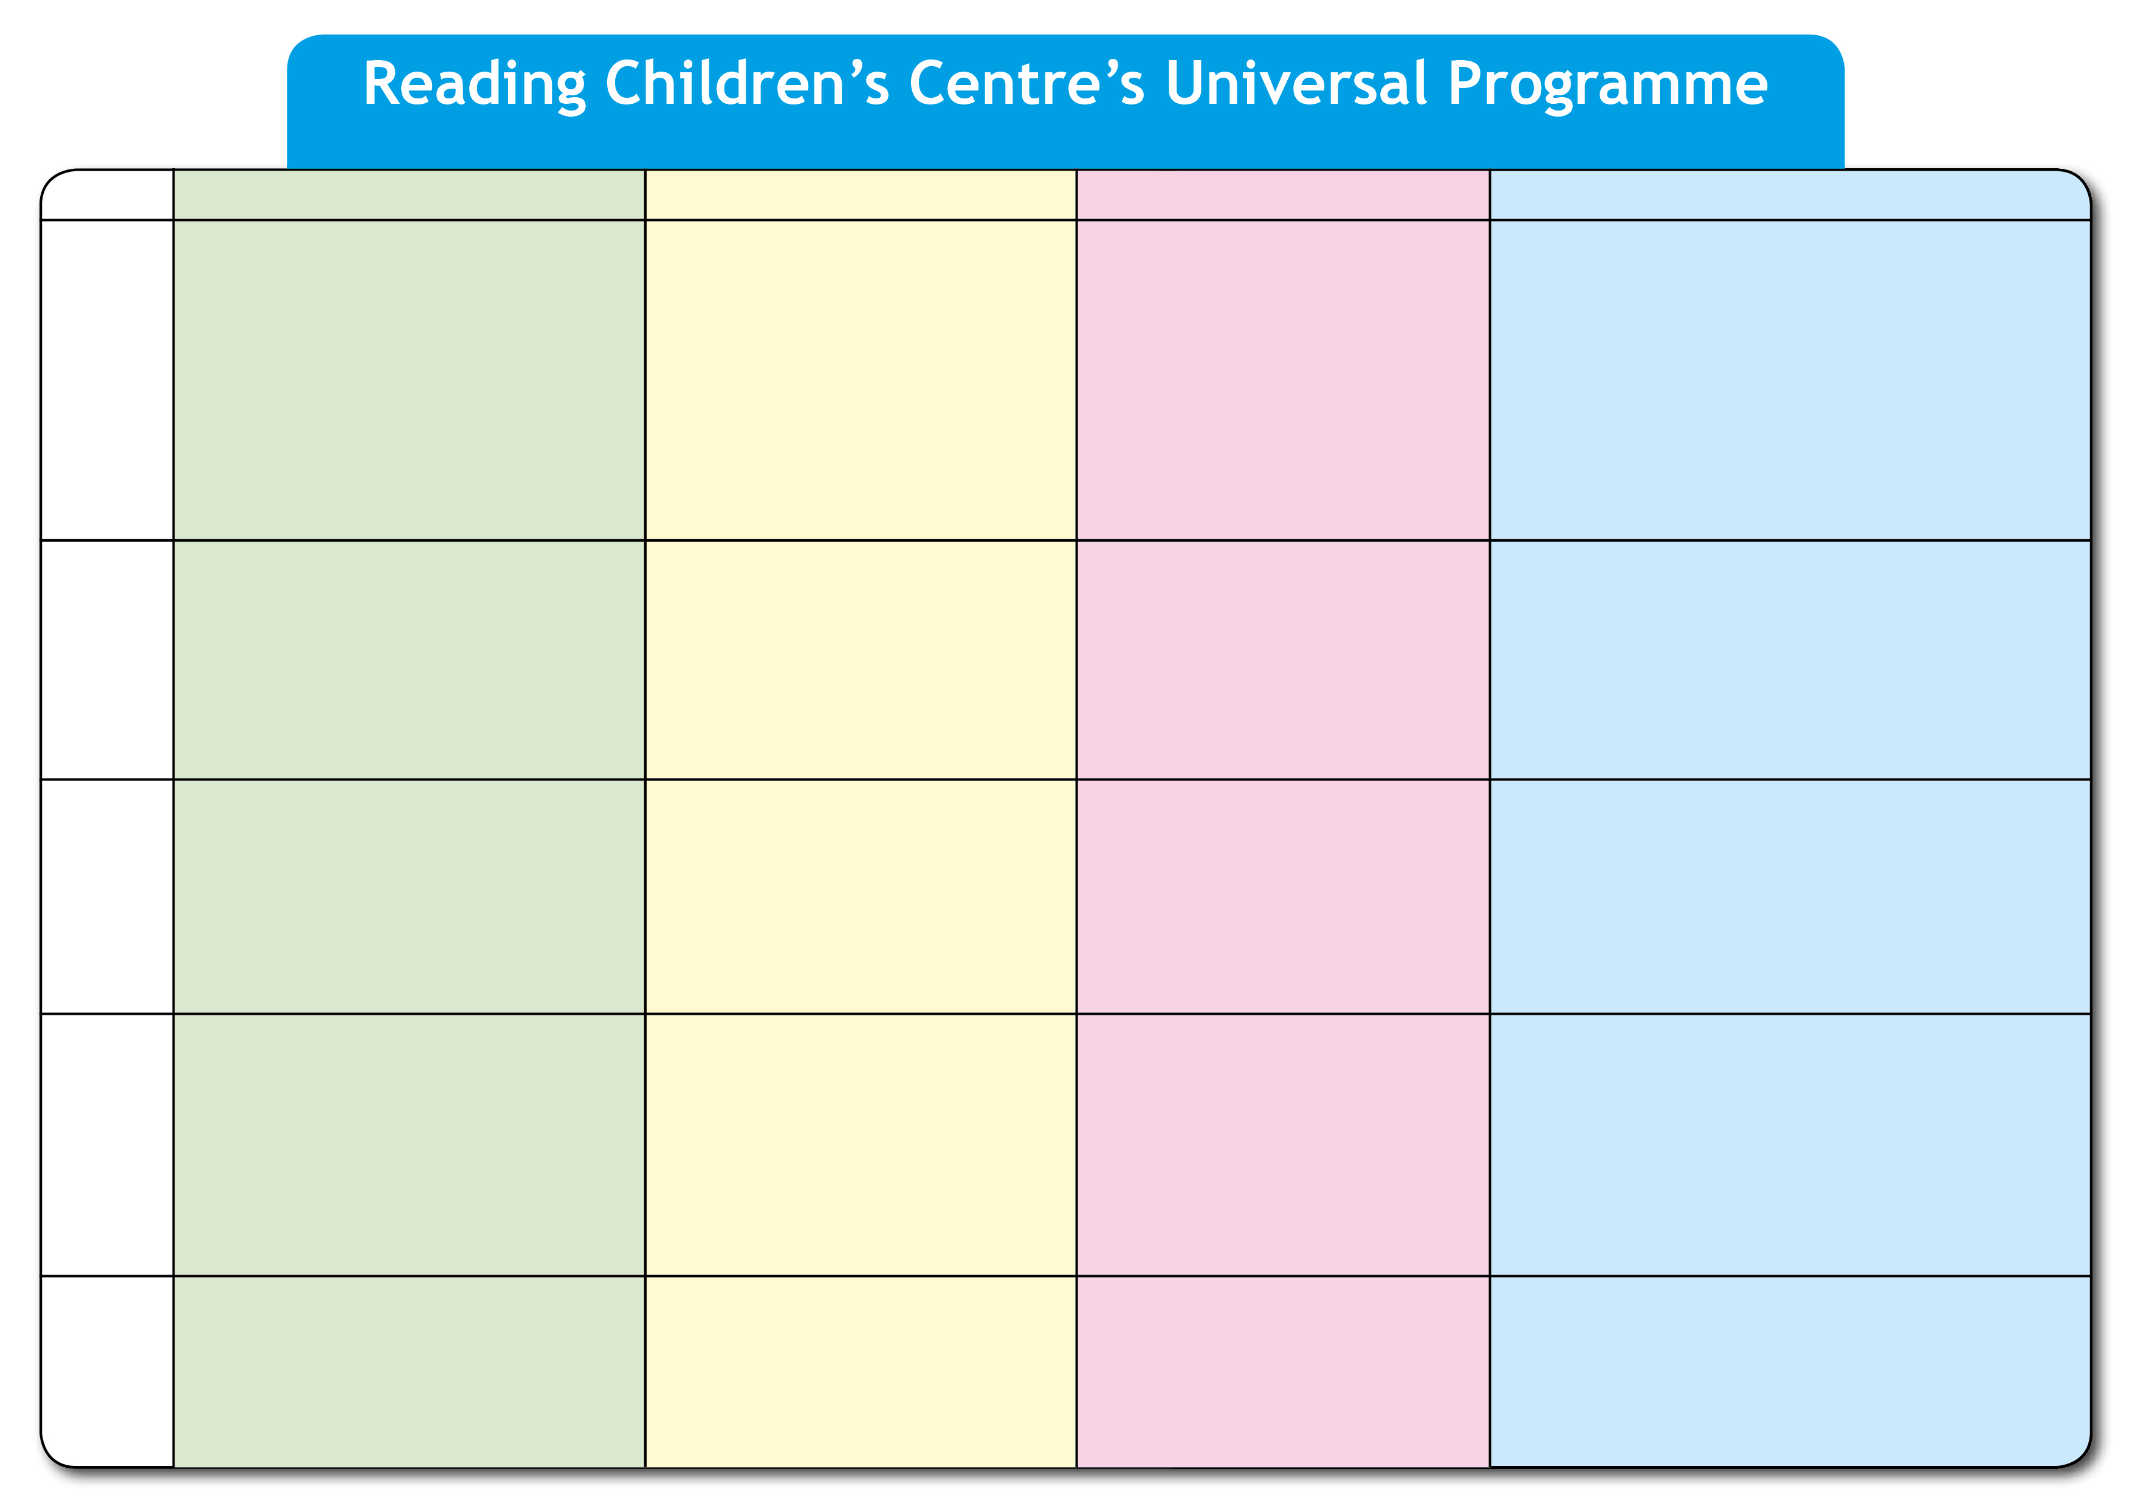



[**Readingchildrencentre**](mailto:ReadingChildrenCentres@reading.gov.uk)**s@brighterfuturesforchildren.org**

Together Time with F.A.M.I.L.Y @ Southcote (9:30-11.00)

Child Health Clinic @ Coley

(1.00-2.00)

Bumps & Babes 0-12 months @ Coley

(1.00-2.15)

NEW DIRECTIONS MATHS @ Southcote

(9.30-11.30 Entry Level) (12:30 – 2:30 Level 2)

Crèche Available for both sessions

Speech and Language Drop in @ Southcote 4th Wednesday of the month (9.00-11.30)

Child Health Clinic @ Southcote (1.00-2.15)

Bumps & Babes 0-12 months @ Southcote (1.00–2.15)

Tiny Talkers @ Coley Booking Required (1.00-2.30)

NEW DIRECTIONS English @ Southcote

(9.30-11.30 & 12.30-2.30) –

Crèche Available

Speech and Language Drop In

3rd Thursday of the month @ Coley (9.00-11.30)

NEW DIRECTIONS Caring for Children Level 2 @ Whitley CC 9.30-11.30 & 12.30-2.30 Crèche Available

Together Time with F.A.M.I.IL.Y @ Whitley (9.30-11.00 & 1.00 – 2.30)

Child Health Reviews @ Whitley Health Centre- Appointment only

Messy Play for 2yr olds @ Whitley 30th Nov 10-11.30

Christmas Extravaganza 19th Dec 10.30-12 (Bookings being taken from 4th Dec)

Child Health Clinic @ Whitley Health Centre (9.30-11.15)

NEW DIRECTIONS Maths & English @ Whitley CC (9.30-11.30 & 12.30-2.30) – Crèche Available

Bumps & Babes 0-12 months @ Whitley CC

10-11.30

Speech and Language Drop in @ Whitley 2nd Tuesday of the month (1.30-4.00)

Tiny Talkers @ Whitley CC 1-2.15

Book Smart @ Ranikhet – Last Friday of every

month - (10.00-11.00am)

**Booking Required**

Child Health Clinic @ Ranikhet (1.00- 2.15)

Bumps and Babes 0-12 months @ Ranikhet

(1.00-2.15)

NEW DIRECTIONS ESOL @ Ranikhet - (10.00-12.00)

Child Health Reviews @ Battle Library

(Appointment only)

Child Health Reviews @ Ranikhet

(Appointment only)

Speech and Language Drop In @ Ranikhet

1st and 3rd Thursday of the month (1.30-4.00)

Child Health Clinic @ Battle Library

(2.15-4.00)

Together Time with F.A.M.I.L.Y @ Ranikhet 10.00-11.30 am

Tiny Tums @ Ranikhet

11th December 10-11am **Booking Required**

NEW DIRECTIONS MATHS @ Ranikhet

(9.30-11.30 & 12.30-2.30) Crèche Available

Child Health Reviews @ Battle Library

(Appointments only)

Bumps and Babes 0-12 months (12.30 - 2.00)

Speech and Language Drop In @ Battle

Library 1st and 3rd Wednesday of the

Month (9.00-12.00)

NEW DIRECTIONS English @ Ranikhet

(9.30-11.30 & 12.30-2.30) – Crèche Available

Child Health Reviews @ Ranikhet

(Appointment only)

Tiny Talkers @ Ranikhet 10-11:30am **Booking Required**

Monday

Tuesday

Wednesday

Thursday

Friday

Child Health Reviews @ Caversham (appointment only)

Speech and Language Drop in @ Caversham, 1st and 3rd Tuesday of the month (9.00-11.30)

Speech and Language Drop In @ Sun Street, 1st Tuesday of every month (9.30–12.00)

Early Explores (1-2 years) @ Sun Street (10-11:30)

Tiny Talkers @ Sun Street, Booking Required (10-11:30)

**Monday 29thOctober – Friday 21st December 2018**

Child Health Clinic @ Caversham (9:30-11:15)

Bumps and Babes 0-12 months (9:45–11:15) with

Breastfeeding network @ Caversham (9:30-11:15)

Child Health Reviews @ Sun street ~ Appointment only

NEW DIRECTIONS English @ Caversham (12:30-2:30) – Crèche Available

**West Cluster**

**South Cluster**

**West Central Cluster**

**East Cluster**

Together Time with F.A.M.I.IL.Y @ Sun Street (10-11:30)

Child Health Clinic @ Sun Street (9.30- 11.00)

Bumps and Babes 0-12 months @ Sun Street (9.30-11.00)

Breastfeeding network @ Sun Street (9.30-11.00)

[**www.**](http://www.reading.gov.uk/childrenscentres)**brighterfuturesforchildren.org**

Together Time with F.A.M.I.L.Y @ Coley (1.00-2.30)

Child Health Reviews @ Southcote (appointment only)

**www.facebook.com/Readingchildrenscentres**